**Webern: Analysis on Variations for Piano op.27**

Anton Webern was an exponent of atonality and twelve-tone technique, he was also one of the core composers in the Second Viennese School, along with his mentor Arnold Schoenberg and his friend Alban Berg. In his book, *The Path to the New Music*, he insisted that twelve-tone music was the result of music’s evolution because it combined the most advanced approaches to pitch (using all twelve chromatic notes), musical space (the integration of harmony and melody), and the presentation of musical ideas, such as combining Classic forms with polyphonic procedures and unity with variety, and deriving every element from the theoretical material.[1] Besides that, Webern also developed the technique in his own way, such as the use of symmetry, which is a significant feature of Webern. This essay will be focusing on his *Variations for Piano, Op.27* and how this work fits into the output of the Second Viennese School.

*Variations for Piano, Op.27*, was composed in 1935 - 1936, and it is the only published solo piano work.[2] This work is a twelve-tone piece, and it consists of three movements. Although the three movements were not composed in the order they appear in the work, he started with the third movement, then first movement, and finished with second movement, this work took him about a year to complete the work.[3] Furthermore, the forms that Webern employed in this work is not strictly following the form of variation. The first movement is a sonata form, the second movement is a binary form, and the third movement is a set of a theme and five variations. However, to refer to an entire work by the form of its last movement is very unusual, and numerous attempts have been made to explain the title.[4]

In the first movement, each section contains a series of two-voice palindrome canons, which is the main structural idea of this movement.[5] It is the combination of the original form and its retrograde form, which creates symmetry.[6] For example, the opening row-forms (bars 1 – 7) shapes as an exact palindrome, with its axis in bar 4.[7] Figure 1 shows the opening phrase of the first movement.

Figure 1 Webern, Variations for Piano, Op.27, First movement, bars 1 – 7

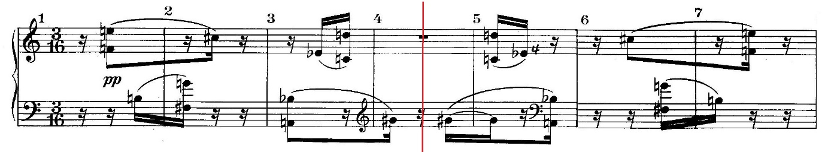

The first half of the original form and the second half of its retrograde form are in the right hand, whereas left hand starting with the first half of the retrograde form, and end with the second half of the original form.[8] Moreover, Webern did not follow the formula strictly. For instance, the phrase (bars 11 – 15) still forms a palindrome, however it is not exactly symmetrical. Figure 2 shows bars 11 – 15 of the first movement.

Figure 2 Webern, Variations for Piano, Op.27, First movement, bars 11 – 15

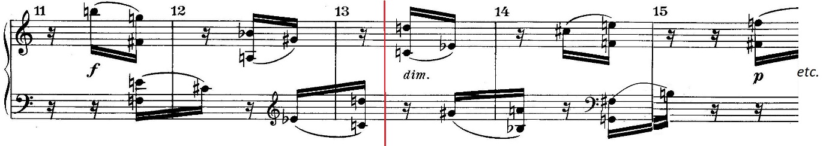

The second movement is the most discussed of the other three, because it applied the development of a stricter, more comprehensive serialism, to the register of pitches.[9] As with the first movement, rows are paired in a series of two-voice canons.[10] This movement includes four pairs of set, each sections uses two canons, one in the right hand and another one in left hand.[11] The reason why these four pairs are selected particularly is because they either begin or end with G-sharp or B-flat.[12] The four canons only use R-RI forms, which are RI0-R0, R2-RI10, and RI5-R7 (used twice).[13] The first half of the movement starts with R0 in the right hand, and RI0 in the left hand, then they swap hands in bar 5, so now right hand has RI0 and left hand has R0. The rows finished in bar 6, right hand continues with R7, and left hand continues with RI5. After that, they swap hands again in bars 8 – 9. Figure 3 shows the first half of the second movement with the rows highlighted.

Figure 3 Webern, Variations for Piano, Op.27, Second Movement, bars 1 – 11

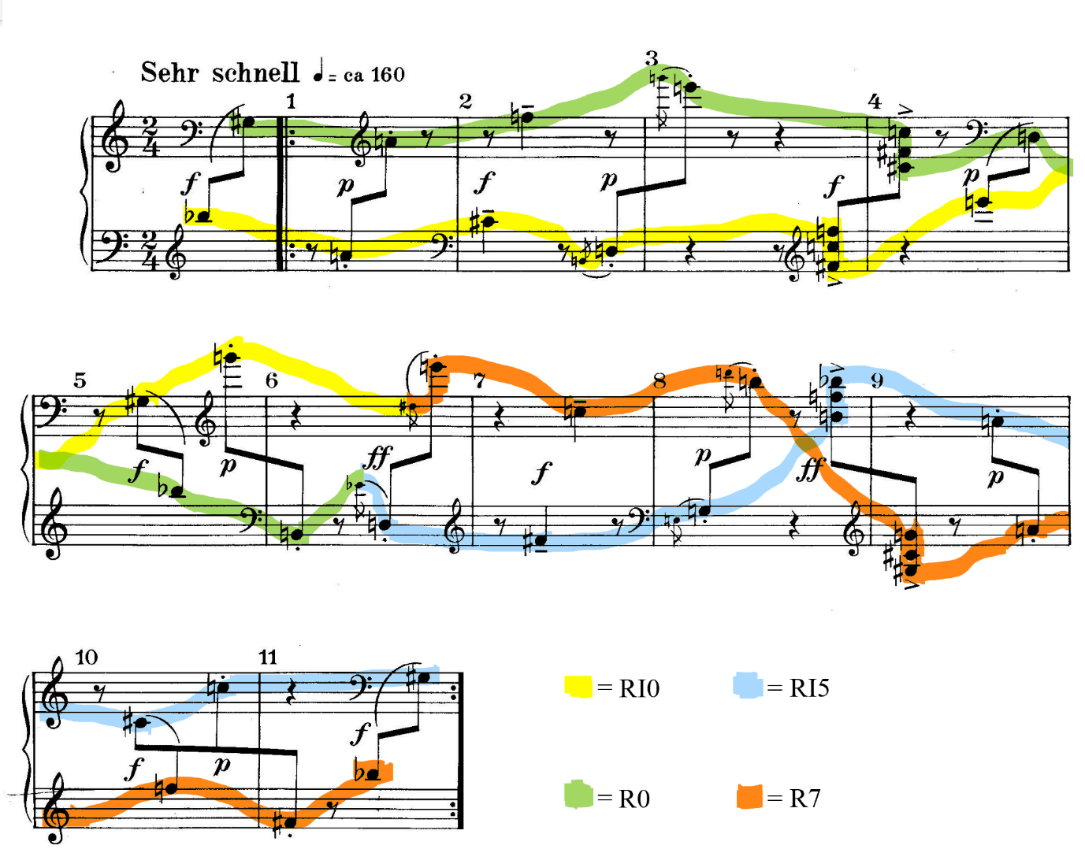

The second half if the movement starts with RI10 in the right hand, and R2 in the left hand. This row-pair (RI10/R2) has one of the most interesting features, which the “voice-exchange” G-B/B-G, occurs in bars 12 – 13.[14] In addition, there are other voice exchanges as well, which functions as a kind of echo, also to extend the dyads exchanged, which happened in bars 15, 13 and 20.[15] After the rows finished, RI10 continues with R5 in the left hand after hands swap, and R2 continues with RI7 in the right hand, in bar 17. Figure 4 shows the second half of the second movement with rows highlighted.

Figure 4 Webern, Variations for Piano, Op.27, Second Movement, bars 11 – 22

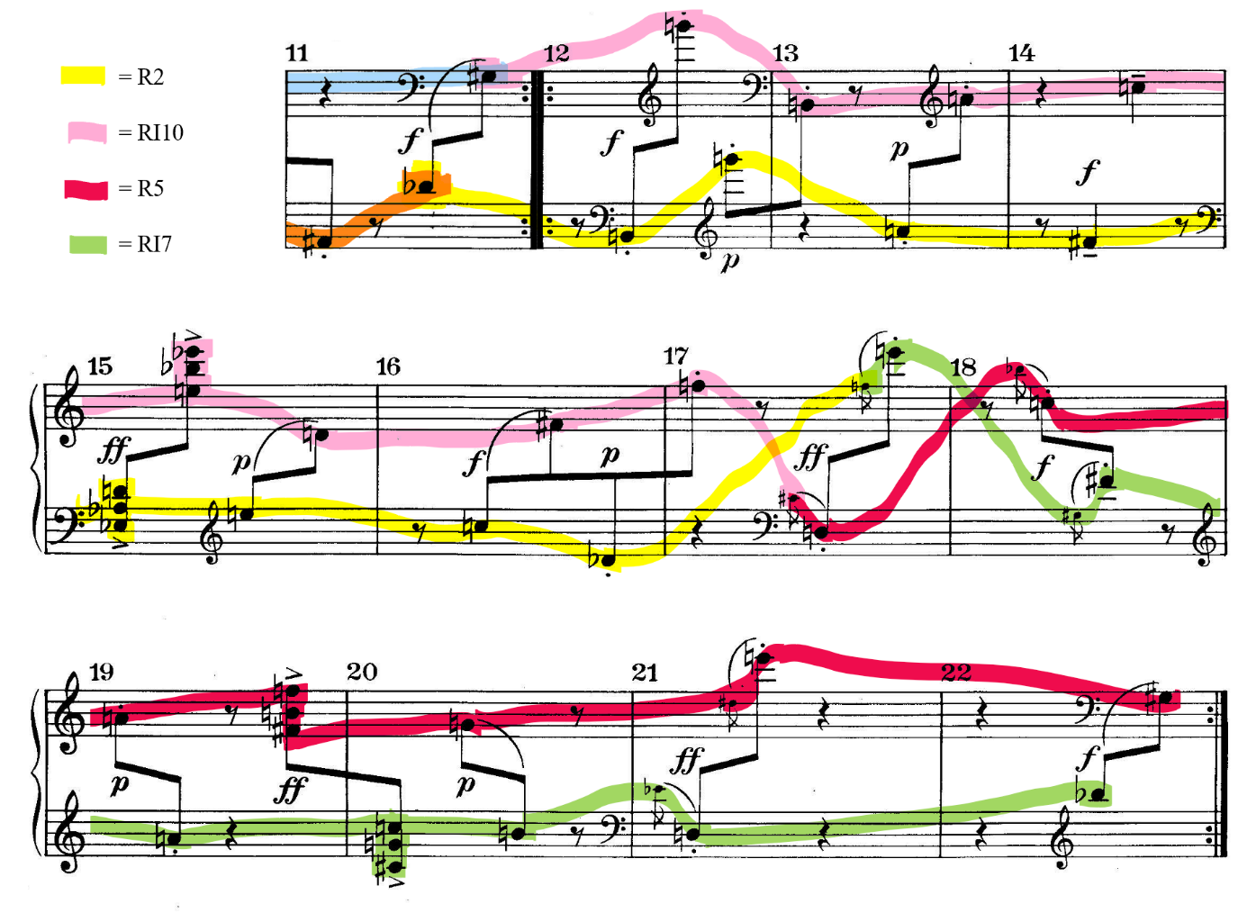

Other than that, As and E-flats/D-sharps have become the pivot, and it is reinforced by the circumstance that in all four pairs, A occurs simultaneously with A, and E-flat with E-flat.[16] Figure 5 shows the chart of the four row-pairs with the coincidence of As, and E-flats highlighted.

Figure 5 Webern, Variations for Piano, Op.27, the chart of the four row-pairs in Second Movement

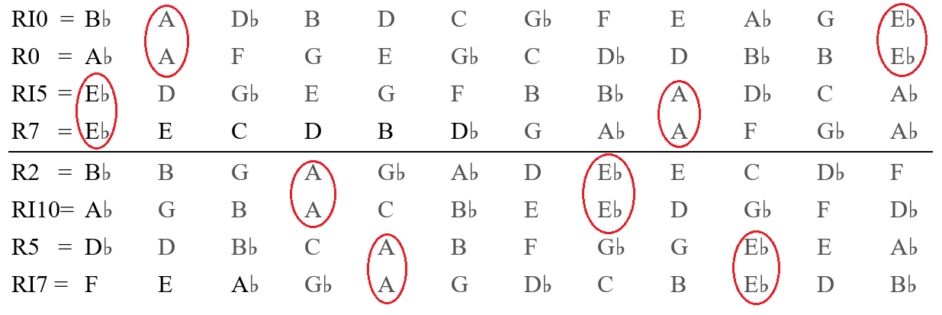

The third movement of his *Variations for Piano* is the only movement strictly written in the variation form.[17] It is also easier to understand and analyze, compare to the first two, because he only uses one row in this movement. Figure 6 shows the prime row of the third movement.

Figure 6 Webern, Variations for Piano, Op.27, the Prime Row of the Third Movement

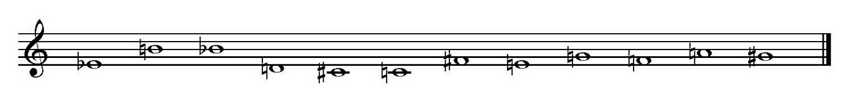

This movement is a set of a theme and five variations, and each of them has around eleven bars. The fixed length of the variation becomes a fundamental aspect of the form, since the variations are not based on a theme or melodic motive.[18] The theme is formed by P0, I0, and R0, which is the combination of the horizontal symmetry from the first movement, where prime forms are placed against retrograde forms, and the vertical symmetry from the second movement where retrograde forms are placed against retrograde-inversion forms.[19]

The first variation starts from bar 12. In this variation, rhythmic pattern is totally changed, and it rests upon motivic references to the theme.[20] For example, bars 11 and 16 demonstrate the theme is compressed.[21] Besides that, the high G-sharp with *fortissimo* marked in bar 19 has become the climax of the variation, which is prepared by the high F-sharp with *subito forte* marked in bar 16.

The second variation is very different with the first variation, because the motif of the trichords, with associated pitches that contained a tritone, which occur in bars 24, 26, 28-29, 31 and 33, is very important in the work.[22] Furthermore, the forms in this variation are all retrogrades and retrograde-inversions, which avoids any chances to create horizontal symmetry.[23]

The third variation is like second variation in some ways, such as the trichord is still playing a similar role.[24] Additionally, the motif in this variation is obviously the quavers.[25] Again, there is clear that horizontal symmetry is here, with a palindrome in bars 34 – 37, also bars 38 – 42.[26]

Before the fourth variation begins in bar 45, it has a bar rest to make it clear that third variation in finish. Likewise, the rhythmic and harmonic ideas from the first variation are now used in fourth variation again.[27] The forms are making an interesting pattern with alternating between retrograde-inverse form and prime form, and each pair of forms is transposed through the cycle of three.[28]

The final variation worked as a coda, which is expecting to be the climax of the piece.[29] Again, this variation is formed by P0, R0 and I0, which is same as the theme.[30] However, the big difference between the theme and final variation is the register of note, in the final variation has lower register, whereas the theme has higher register.[31] It begins with the P0 and moves into a horizontal symmetry with R0 in bars 56 – 59, although it is not exactly a palindrome.[32] Other than that, there is another horizontal symmetry occurred in bars 59 – 63, with the row-pair of I1 and RI1.

In conclusion, Webern’s *Variations for Piano, Op.27*, is undoubtedly fit into the output of the Second Viennese School. Because this work demonstrated that the mature use of twelve-tone technique, and also Webern’s stylistic and extended techniques on twelve-tone music is obvious, such as the horizontal and vertical symmetry, the combination of two different rows to create one row, two canons play simultaneously and so on. Webern’s music is pure and individual, due to his systematic way to compose, his focus on structure and unity, and the unique sound of his music.[33] However, he did not get wide popularity with his music, and only scholars and composers recognized his works at that time.[34] His music exerted influence on some modern composers, such as Dallapiccola, Elston, and even his mentor Schoenberg, especially in the first two decades after the war.[35]

**Bibliography**

**Books**

1. Burkholder, Peter J, Grout, Donald Jay, and Palisca, Claude V: *A History of Western Music*, 9th edition. (New York and London: W.W. Norton and Co., 2014)
2. Bailey, Kathryn: *The Life of Webern* (Cambridge: Cambridge University Press, 1998)
3. Bailey, Kathryn: *The Twelve-Note Music of Anton Webern* (Cambridge: Cambridge University Press, 1991)
4. Morgan, Robert P.: *Twentieth-Century Music* (New York: W.W. Norton and Co., 1991)
5. Whittall, Arnold: *Musical Composition in the Twentieth Century* (Oxford University Press: 2000)

**Articles in Journals**

1. Wason, Robert W.: ‘Webern's "Variations for Piano", Op. 27: Musical Structure and the Performance Score’,Intégral, Vol.1 (1987), 57-103.

**Music Score**

1. Webern, Aton: *Variation for Piano, Op.27* (Vienna: Universal Edition, 1937)

1. Burkholder, Peter J, Grout, Donald Jay, and Palisca, Claude V: *A History of Western Music*, 9th edition. (New York and London: W.W. Norton and Co., 2014), 828.
2. Bailey, Kathryn: *The Life of Webern* (Cambridge: Cambridge University Press, 1998), 151.
3. Bailey, Kathryn: *The Twelve-Note Music of Anton Webern* (Cambridge: Cambridge University Press, 1991), 452.
4. *Ibid*, 189-190.
5. Morgan, Robert P.: *Twentieth-Century Music* (New York: W.W. Norton and Co., 1991), 207.
6. *Ibid*.
7. *Ibid*.
8. Morgan, Robert P.: *Twentieth-Century Music* (New York: W.W. Norton and Co., 1991), 208.
9. Whittall, Arnold: *Musical Composition in the Twentieth Century* (Oxford University Press: 2000), 211.
10. *Ibid*.
11. *Ibid*.
12. *Ibid*.
13. Wason, Robert W.: ‘Webern's "Variations for Piano", Op. 27: Musical Structure and the Performance Score’,Intégral, Vol.1 (1987), 57-103, (p. 91)
14. Wason, Robert W.: ‘Webern's "Variations for Piano", Op. 27: Musical Structure and the Performance Score’,Intégral, Vol.1 (1987), 57-103, (p. 91)
15. *Ibid*, 94.
16. Whittall, Arnold: *Musical Composition in the Twentieth Century* (Oxford University Press: 2000), 211.
17. Bailey, Kathryn: *The Twelve-Note Music of Anton Webern* (Cambridge: Cambridge University Press, 1991), 211.
18. Bailey, Kathryn: *The Twelve-Note Music of Anton Webern* (Cambridge: Cambridge University Press, 1991), 56.
19. Wason, Robert W.: ‘Webern's "Variations for Piano", Op. 27: Musical Structure and the Performance Score’,Intégral, Vol.1 (1987), 57-103, (p. 73)
20. *Ibid*, 83
21. *Ibid*.
22. *Ibid*, 86
23. *Ibid*.
24. *Ibid*, 87.
25. *Ibid*.
26. *Ibid*.
27. Wason, Robert W.: ‘Webern's "Variations for Piano", Op. 27: Musical Structure and the Performance Score’,Intégral, Vol.1 (1987), 57-103, (p. 88)
28. *Ibid*.
29. *Ibid*, 89.
30. *Ibid*, 90.
31. *Ibid*.
32. *Ibid*, 89.
33. Burkholder, Peter J, Grout, Donald Jay, and Palisca, Claude V: *A History of Western Music*, 9th edition. (New York and London: W.W. Norton and Co., 2014), 829.
34. *Ibid*.
35. *Ibid*, 830.